Bahria University,

Karachi Campus



LAB EXPERIMENT NO.

**04**

LIST OF TASKS

|  |  |
| --- | --- |
| TASK NO. | OBJECTIVE |
| **1** | **Make a Calculator! using prompt(), and variables, make a program that does the following:**  **i Prompts the user for first number.**  **ii Stores that first number**  **iii Prompts the user for the second number**  **Iv Asks which operation does it want to perform (+,-,/,*,++,--,%)**  **V Stores that result and responds with the calculated value by using an alert** |
| **2** | **using this array**  **var array = ["Banana", "Apples", "Oranges", "Blueberries"];**  **1. Remove the Banana from the array.**  **2. Sort the array in order.**  **3. Put "Kiwi" at the end of the array.**  **4. Remove "Apples" from the array.**  **5. Sort the array in reverse order. (Not alphabetical, but reverse// the current Array i.e. ['a', 'c', 'b'] becomes ['b', 'c', 'a'])** |
| **3** | **Alarm ringing !**  **I Suppose by default there is a prompt saying “ Alarm is ringing”. Press ‘S’ to snooze and ‘D’ to dismiss**  **II If user selects ‘D’, program will be dismissed with a prompt “Good Morning”**  **III If user select ‘S’ , the program “ Alarm is ringing”. Press ‘S’ to snooze and ‘D’ to dismiss will rerun and again the prompt will be (repeat from step I)**  **IV upon entering wrong input program will prompt “wrong input” and program ends.** |
| 4 | Create an object and an array which we will use in our facebook exercise.  Create an object that has properties "username" and "password". Fill those values in with strings.  Create an array which contains the object you have made above and name the array "database".  Create an array called "newsfeed" which contains 3 objects with properties "username" and "timeline". |

Submitted On:

**TASK 1:**

**Make a Calculator! using prompt(), and variables, make a program that does the following:**

**i Prompts the user for first number.**

**ii Stores that first number**

**iii Prompts the user for the second number**

**Iv Asks which operation does it want to perform (+,-,/,*,++,--,%)**

**V Stores that result and responds with the calculated value by using an alert**

**CODE:**

const operator = prompt('Enter operator (either +, -, /,* , ++ , -- , %): ');

const number1 = parseFloat(prompt('Please Enter First number: '));

const number2 = parseFloat(prompt('Please Enter Second number: '));

let result;

if (operator == '+') {

    result = number1 + number2;

}

else if (operator == '-') {

    result = number1 - number2;

}

else if (operator == '*') {

    result = number1 * number2;

}

else if (operator =='/'){

    result = number1 / number2;

}

else if (operator == '++'){

    result= number1+number2+1;

}

else if (operator == '--'){

    result= number1-number2-1;

}

else{

    result= number1/number2*100;

}

alert(`${number1} ${operator} ${number2} = ${result}`);

**OUTPUT:**

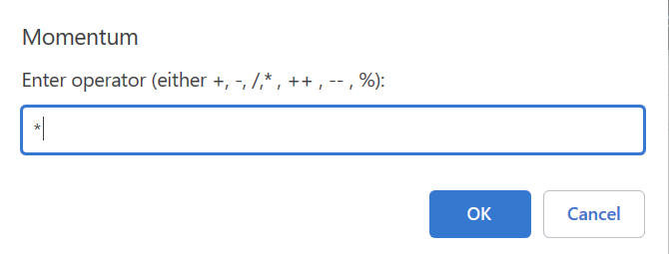

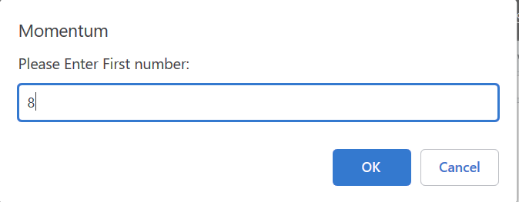

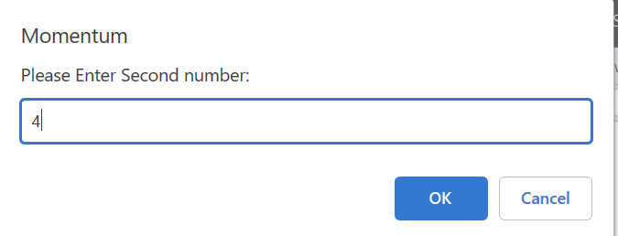

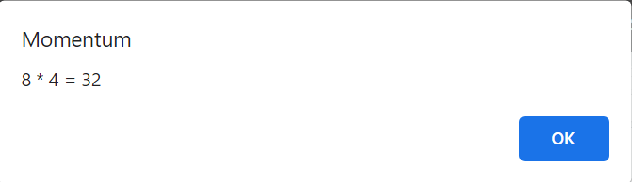

**TASK 2:**

**using this array**

**var array = ["Banana", "Apples", "Oranges", "Blueberries"];**

**1. Remove the Banana from the array.**

**2. Sort the array in order.**

**3. Put "Kiwi" at the end of the array.**

**4. Remove "Apples" from the array.**

**5. Sort the array in reverse order. (Not alphabetical, but reverse// the current Array i.e. ['a', 'c', 'b'] becomes ['b', 'c', 'a'])**

**CODE:**

var array = ["Banana", "Apples", "Oranges", "Blueberries"];

console.log(array)

array.shift();

console.log(array)

array.sort();

console.log(array)

array.push("Kiwi");

console.log(array)

/* At position 0 remove 1 */

array.splice(0, 1);

console.log(array)

array.reverse();

console.log(array)

**OUTPUT:**

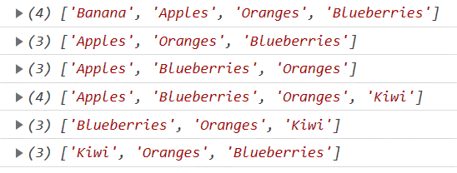

**TASK 3:**

**Alarm ringing !**

**I Suppose by default there is a prompt saying “ Alarm is ringing”. Press ‘S’ to snooze and ‘D’ to dismiss**

**II If user selects ‘D’, program will be dismissed with a prompt “Good Morning”**

**III If user select ‘S’ , the program “ Alarm is ringing”. Press ‘S’ to snooze and ‘D’ to dismiss will rerun and again the prompt will be (repeat from step I)**

**IV upon entering wrong input program will prompt “wrong input” and program ends.**

**CODE:**

var options=prompt('Alarm is Ringing!! Press S to Snooze and D to Dismiss !');

if(options=='S'||options=='s')

{while(options=='S'||options=='s')

{options=prompt('Alarm is Ringing!! Press S to Snooze and D to Dismiss !');}

alert('Wrong Input');}

else if(options=='D'||options=='d')

{alert('Good Morning')}

else{alert('Wrong Input');}

**OUTPUT:**

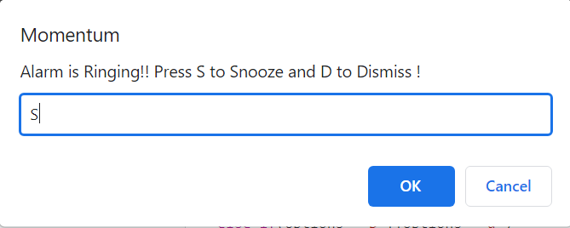

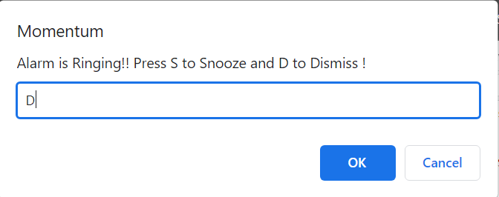

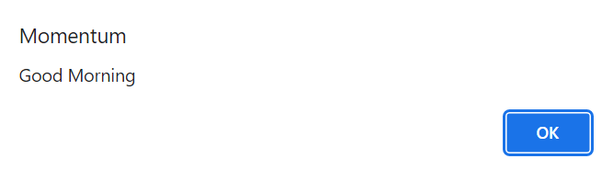

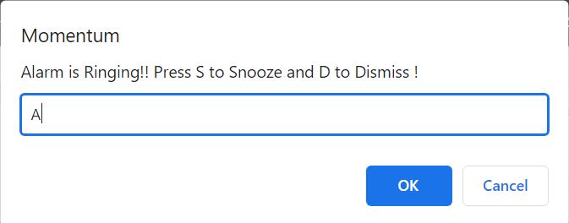

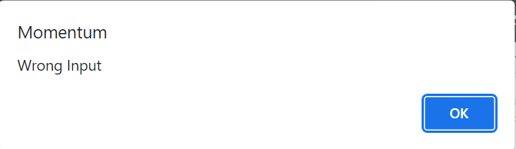

**TASK 4:**

**Create an object and an array which we will use in our facebook exercise.**

**Create an object that has properties "username" and "password". Fill those values in with strings.**

**Create an array which contains the object you have made above and name the array "database".**

**Create an array called "newsfeed" which contains 3 objects with properties "username" and "timeline".**

**OUTPUT:**

1. **Create an object that has properties "username" and "password". Fill those values in with strings.**

let user ={

    username : "Shoaib" ,

    Password : "shah"

}

1. **Create an array which contains the object you have made above and name the array "database".**

let database = [ {

    username : "Shoaib" ,

    Password : "shah"

}]

1. **Create an array called "newsfeed" which contains 3 objects with properties "username" and "timeline".**

let newsfeed = [

    {

        username : "Shoaib" ,

        Timeline : "shah"

    },

    {

        username : "Syed" ,

    Timeline : "M Shoaib"

    },

    {

        username : "task4" ,

        Timeline : "Facebook"

}

]

console.log(user)

console.log(database)

console.log(newsfeed)